Unit 6 Study Guide
~~~~~~~~~~~~~~~~~~~~~~~~~~~~~~~~~~~~~~~~~~~~~~~~~~~~~~~~~~~~~~~~~~~~~~~~~~~~~~~~~~~~~~~~~~~~~~~~~~

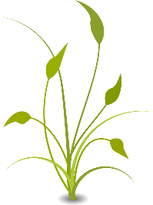
Critical Vocabulary:
(1.) Photosynthesis (2.) Cellular Respiration (3.) Reactant (4.) Product (5.) Carbon Cycle (6.) Producer (7.) Consumer (8.) Herbivore (9.) Carnivore (10.) Energy Pyramid (11.) Chloroplast (12.) Chlorophyll (13.) Trophic Level (14.) Law of Conservation of Mass (15.) Law of Conservation of Energy
~~~~~~~~~~~~~~~~~~~~~~~~~~~~~~~~~~~~~~~~~~~~~~~~~~~~~~~~~~~~~~~~~~~~~~~~~~~~~~~~~~~~~~~
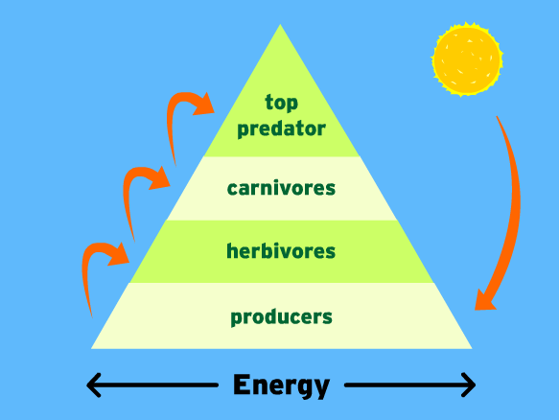
(16.) Which trophic level of the energy pyramid would have the largest population of organisms?
(17.) Which level of the energy pyramid would contain the PRIMARY CONSUMERS?
(18.) Why is the energy pyramid shaped like a triangle? (Clarification: why is it becoming
narrower as you navigate up the food chain?)
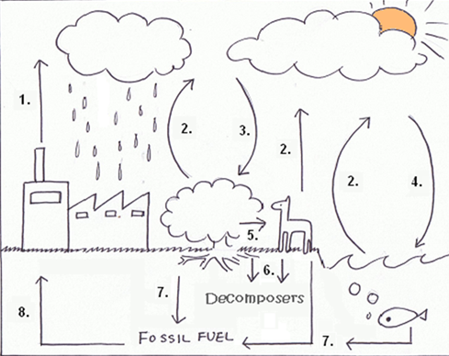
~~~~~~~~~~~~~~~~~~~~~~~~~~~~~~~~~~~~~~~
CARBON CYCLE DIAGRAM
(19.) Which process within the carbon cycle is indicated by arrow #2?
(20.) What is the only major process that REMOVES carbon from the atmosphere?
(21.) Will carbon always travel the same pathway? Explain.
(22.) What are the reactants and products of photosynthesis?
(23.) What are the reactants and products of cellular respiration?
(24.) In most cases, which part of the plant retrieves a.) CO₂ b.) H₂O and c.) Sunlight to successfully complete photosynthesis?
(25.) What type of organisms use cellular respiration for daily activities?

