- What is the difference between weight and mass?

- Classify the following as a chemical or physical property/change: Reactivity, melting, burning (flammability), magnetism, rusting, electrical conductivity, thermal conductivity, density. NOTE: NOT ALL SLOTS WILL BE FILLED
Physical Property/ Change | Chemical Property/ Change
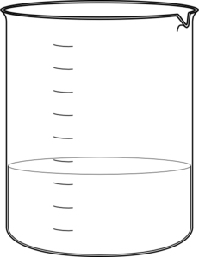
- A student has two beakers, each containing 150 ml of water (solvent). The student adds salt to beaker #1 until no more will dissolve. The student adds sugar to beaker #2 until no more will dissolve. The amounts of each solute dissolved are shown to the right. Which statement is most accurate?
  - Salt is more soluble in water than sugar
Beaker 1 (salt) Beaker 2 (sugar)
25g 43g
  - Salt and sugar are equally soluble in water
  - Sugar is more soluble in water than salt.
  - Salt and sugar are both insoluble in water.

g/ml
g/ml
g/ml
g/ml
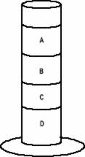
- Rank the following densities as they would appear in a density column.
1.0 g/ml, 0.7 g/ml, 1.1 g/ml 0.9 g/ml

- On Earth, a basketball has a mass of 60g. How would the mass and weight of the basketball register on Mars, which is a smaller planet?
  - The mass would be greater and the weight would remain constant on Mars.
  - The mass would be less and the weight would remain constant on Mars.
  - The mass would remain constant and the weight would be less on Mars.
  - The mass would remain constant and the weight would be greater on Mars.
- Mass is a measure of the amount of _______________ an object has.
- If an astronaut takes a golf ball to the moon, circle the properties that would remain the same on Earth as on the moon.
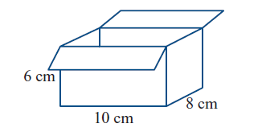
  - Density, Mass, Volume, Weight

- At what point is a solution considered SATURATED?

- Calculate the volume of the cardboard box to the right: _________cm³
- The same cardboard box has a mass of 60g. What is the density of the box? _________g/cm³
- A block of wood has a volume of 45cm³ and a density of .65g/cm³. What is the mass of the wood?
- Complete the density triangle located to the right:

