UNIT 10 STUDY GUIDE- EARTH, MOON, SUN

Pages 200-225 in Fusion Text

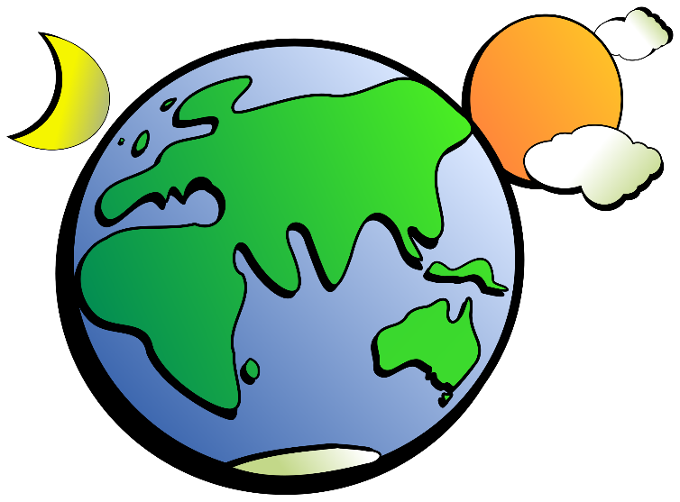
VOCABULARY TO KNOW:
- Rotation/Revolution
- Season
- Satellite
- Tidal Range
- Spring Tide
- Neap Tide
- Lunar Phases
- Solar Eclipse
- Lunar Eclipse
- New Moon/Full Moon

11. Sketch the positioning of the Earth and Sun to show winter in the Southern Hemisphere.

12. Sketch the positioning of the Earth and Sun to show winter in the Northern Hemisphere.

13. Sketch the positioning of the Earth and Sun to show the strongest possible tides.

14. Sketch the positioning of the Moon, Earth, and Sun during a solar eclipse.

15. Sketch the positioning of the Moon, Earth, and Sun during a lunar eclipse.

16. Sketch the positioning of the Moon, Earth, and Sun during a new moon.

17. Sketch the positioning of the Moon, Earth, and Sun during a full moon.

18. Sketch the first lunar phase following a new moon (when the moon is “born”).

CONSIDER THE FOLLOWING:
19. Why does the sun appear to move across the sky each day?
20. Why does the moon shine at night?
21. Why do the moon phases occur once a month?
22. Why do tides occur?
23. T/F When the moon is in a new moon phase, it is receiving no sunlight.
24. T/F The Sun has the greatest influence on tides because it is larger than the Moon.
25. T/F The Moon is a satellite of the Earth.

