

**Physical Change:** no new substance is produced; may involve a change of state; is usually reversible

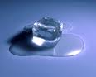

**Chemical Change:** one or more new substances are produced; usually involve heat or light being released, an odor, a color change, and/or a gas being formed; difficult to reverse

Matter Phases of Matter

Atomic Structure

Atoms are the smallest unit of an element

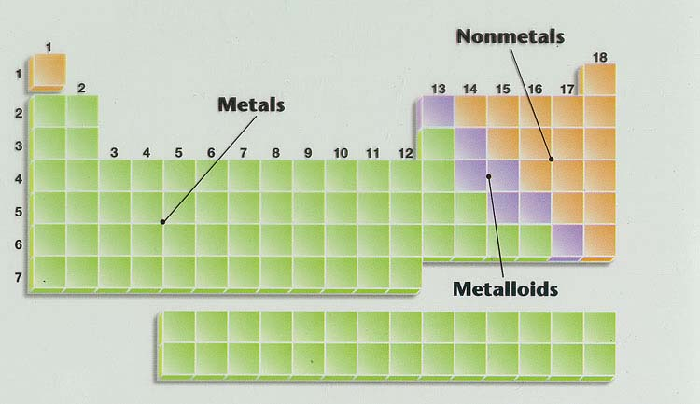

Periods (Rows)

Groups (Columns)

Periodic Table pH Scale

**Atomic Number = number of protons/electrons**

**Atomic Mass = number of protons + number of neutrons**

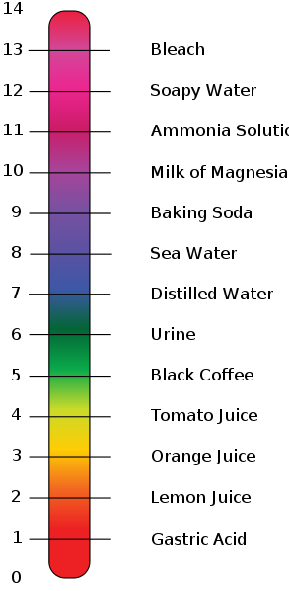

**Factors in an Experiment**

**Dependent Variable:** factor being measured (also called outcome variable), always indicated on the y axis when graphed

**Independent Variable:** factor being altered (also called the test variable), always indicated on the x axis when graphed

**Control:** standard used for comparison to the experimental data

**Constant:** factor(s) that do(es) not change so that a relationship between the independent and dependent variables can be established

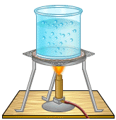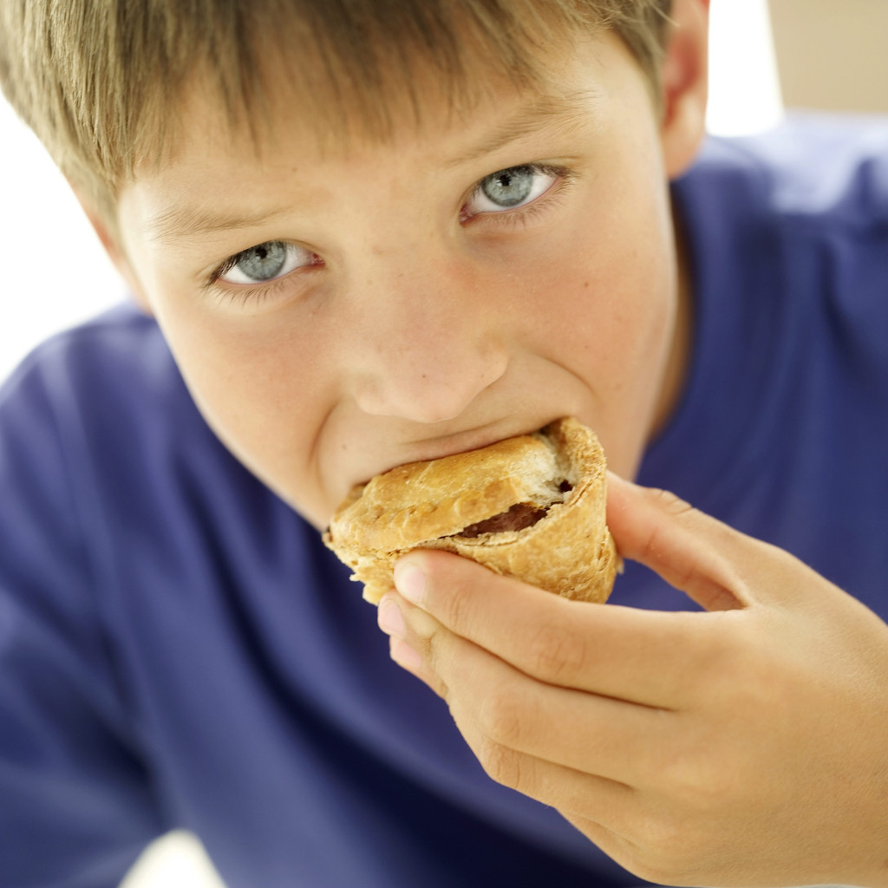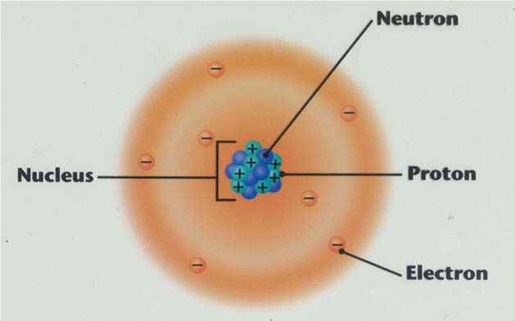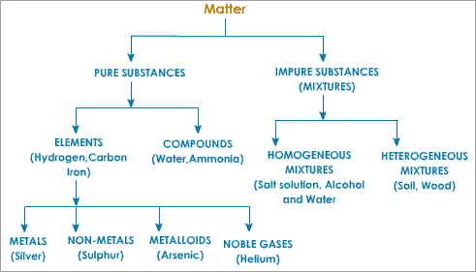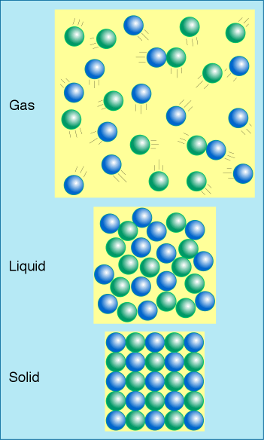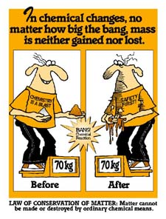

**Law of Conservation of Energy**

Light

* White light is made up of many colors
* Visible light is part of a broader electromagnetic spectrum

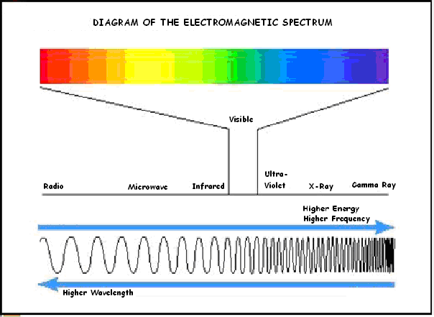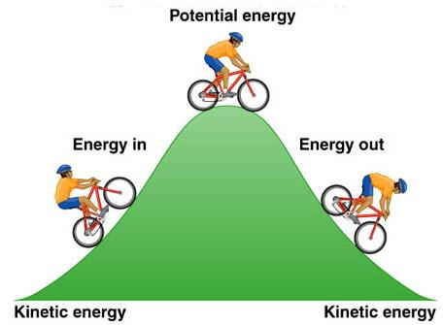

Decreasing P.E.

Increasing K.E.

Increasing P.E.

Decreasing K.E.

**Mass ≠ Weight**

**Mass = amount of matter in a substance**

**measured in kilograms (kg)**

**Weight = force on that matter by gravity**

**measured in Newtons (N)**

**Gravity on Earth is 6 times greater than gravity on the Moon.**

**Weight changes when gravity changes. Mass does not change.**

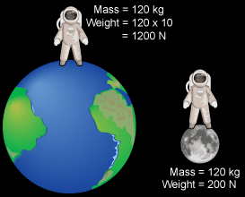

**Heat Transfer**

Always from Warmer to Cooler objects

**90oC 10oC**



**Unbalanced Forces**

**Create or change motion**

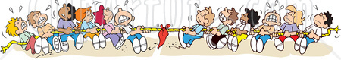

Mass = 120 kg

Weight = 1176 N

**Distance vs. Time Graph**

Stopped

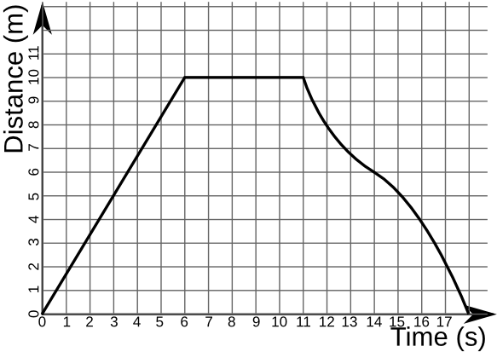

Changing speed

Mass = 120 kg

Weight = 192 N

Density

Density of

Water = 1 g/mL

Constant speed

