6th-8th Grade Nature of Science Review (SC.6-8.N.1-)
On a separate sheet of paper, copy and complete the data table below:
Variable Type | Definition
Independent Variable (Test Variable) | #1
#2 | The data collected by the scientist; what is measured as a result of the test variable
Control Variable | #3

Keesha did an experiment to study the rate of photosynthesis in the water plant Elodea. She placed a piece of Elodea in a beaker of water and set the beaker 10 centimeters from a light source. Keesha counted the bubbles released from the plant every minute for five minutes. She repeated the process two more times. First, she moved the light to 20 cm from the beaker,
and then she moved the light to 30 cm from the beaker. Her data is shown below:
Number of Bubbles
Time in minutes | Distance
 | 10 cm | 20 cm | 30 cm
1 | 30 | 5 | 1
2 | 29 | 5 | 1
3 | 31 | 6 | 3
4 | 31 | 4 | 2
5 | 30 | 4 | 2

4) What was the purpose of Keesha’s experiment?
5) What was Keehsa’s dependent variable (outcome variable)?
6) What was Keesha’s independent variable (test variable)?
7) What did she use to measure the rate of photosynthesis?
8) A classmate of Keesha’s decided to replicate her experiment. However, the classmate did not submerge the Elodea in water. Would the classmate still be able to obtain the same results? Why or why not?

9.) Jami used her cell phone GPS to determine the distance in kilometers the bus travels away from school during a field trip. What type of information can be determined regarding the trip using the graph below?
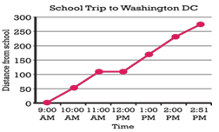
10.) Cameron wants to determine which battery brand he should use for a camping trip. He conducts an experiment and records the data. Using the graph Cameron created below, answer the following:
a.) What is the scientific problem statement for this experiment?
b.) What are the independent (test) and dependent (outcome) variables?
c.) According to the data, which battery is best? Which is worst?
d.) How could Cameron improve the reliability of his results?
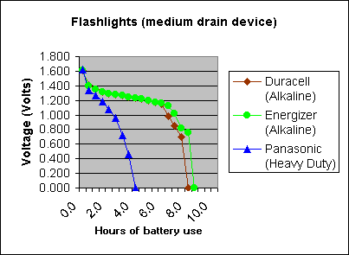

11.) A car company is testing a brake pad model to potentially manufacture. The company wants to determine if the new pad helps the car come to a stop at a faster rate. Four trials are conducted and data is presented to the CEO of the company.
 | CAR 1 W/ NEW BRAKES | CAR 2 ORIGINAL
TRIAL 1 | 4.18s | 5.57s
TRIAL 2 | 4.12s | 5.38s
TRIAL 3 | 5.38s | 6.24s
TRIAL 4 | 5.56s | 6.89s
a.) What is the independent (test) variable?
b.) What is the dependent (outcome) variable?
c.) What are the results of the car company’s experiment?
12.) Design (5) potential scientific investigations (ex. how does shoe type affect running speed) Label test and outcome variables.
13.) What are some characteristics of a high quality experimental conclusion?
14.)

