6th-8th Grade Nature of Science Review (SC.6-8.N.1-)
For each example, determine if it’s an (1) experiment, model, or observation and (2) if the scientist is studying biology, geology, or physics:
1) Ms. Laury goes to the beach every day to watch the nesting habits of birds. She records what she sees in her EcoLog.
2) Ms. Cossin uses a plastic fish, beach sand, and soil to demonstrate how fossils form inside rock layers.
3) Ms. Williams investigates how the shape of an object affects the rate at which it falls from 50 feet. She uses 3 clay pieces molded into a cube, a ball, and a flat sheet.
4.)Mr. Gardner collects igneous rock samples in Hawaii and then examines their crystalline structure in his laboratory.
4) The atomic model has been updated many times. What caused scientists to change the atomic model?
5) Scientists often repeat the experiments of others in order to find evidence that supports or fails to support a theory. Why is replication of experiments important?
6) A scientist did an experiment to see if a skin cream would help reduce the effects of sunburn. During the experiment he discovered that his cream doesn’t help sunburn, but it does heal papercuts. Should the scientist stop because he’s wrong? Explain
Law of Conservation of Mass/Energy
Law of Superposition
Law of Universal Gravitation
Cell Theory
Theory of Evolution by Natural Selection
Theory of Plate Tectonics
Match each example to its theory or law in the table to the right.

7) Charles Darwin studied finches to explain how animals adapt to their environments and animals with the right adaptations for their environment survived and reproduced.
8) Isaac Newton created mathematical formulas to
describe the gravitational attraction between any two objects.
9) Using rock layers to determine which section of a mountain are the oldest.
10) Scientists believe that the tectonic plates are shifting due to the convection motion of the mantle underneath the crust.
11) Matter and energy can’t be created or destroyed, only transformed.
12) Sanitization is important because even if one bacteria cell is
behind, it can replicate to create more bacterial cells.

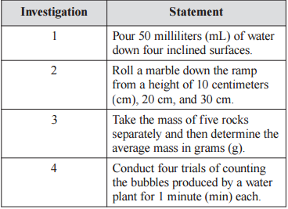
13.) Compare and contrast theories and laws.
14.) What is the difference between repetition and replication? Provide an
example of each.
15.) Which investigation to the right demonstrates an example of repetition?
16.) Scientific knowledge may change as new evidence or information is discovered. Which of the following would NOT be a result of new scientific research and information?
A. Binomial nomenclature is assigned to a recently identified plant species.
B. An endangered monkey species is put in a reserve for protection from extinction.
C. A discovered chemical element will be added to the periodic table of the elements.
D. A nonnative plant species will begin to reproduce rapidly after being introduced
into a swamp ecosystem.
17.) Why are scientific models beneficial to scientists?
18.) Two types of models that can be used to show details of the structures of cells are shown below.
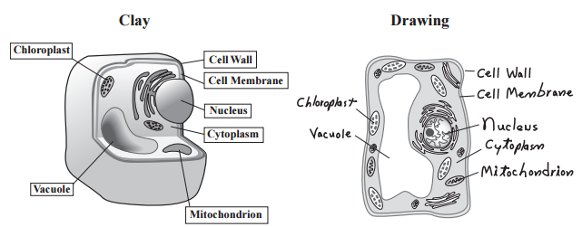
Which of the following describes a limitation of the drawing but NOT the clay model?

A. It does not represent the main parts of a cell.
B. It does not contain the correct number of
nuclei.
C. It cannot represent a living cell, since a true cell
is three-dimensional.
D. It cannot represent a living cell, since the
cytoplasm should be in constant motion.

