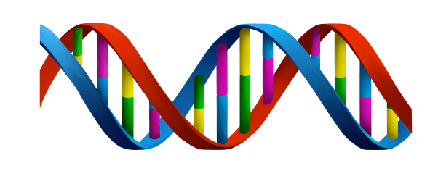
7th Grade Review- Reproduction and Heredity (SC.7.P.16.1-3)

QUESTIONS 1-8: COMPLETE THE PASSAGE AND TABLE BELOW
________ is the complex molecule that provides instructions for organisms to live and function. It is located in structures called _____________ (humans have 23 pairs). DNA can be found in the nucleus of each and every eukaryotic cell. __________ is the passage of these instructions from one generation to another. Chunks of DNA that code for instructions are called ________.

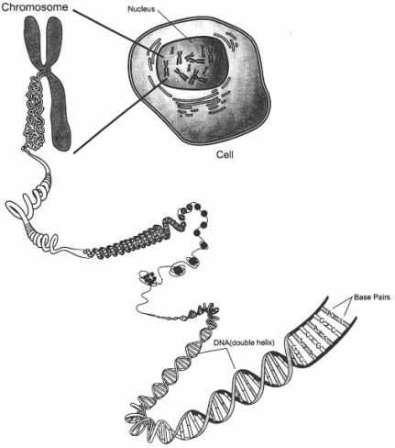
MITOSIS | MEIOSIS
Used for | Used for sexual reproduction
Daughter cells have identical DNA | Daughter cells have
Creates somatic (body) cells | Creates
Also used by some organisms to reproduce (ex. Bacteria) | Only used by _____________  _______________organisms

9.) Freckles are recessive. No freckles are dominant. Mom= heterozygous (Ff) Dad=homozygous recessive (ff). What are the possible outcomes for kids in percentages?

10.) Fat toes are dominant (T) to skinny toes (t). What are the possible outcomes for offspring in percentages for two heterozygous parents?

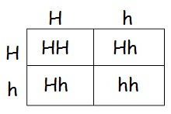
11.) Examine the Punnett Square to the left. What is the genotype of the missing parent?

12.) Explain the difference between genotype and phenotype. Provide an example of each.

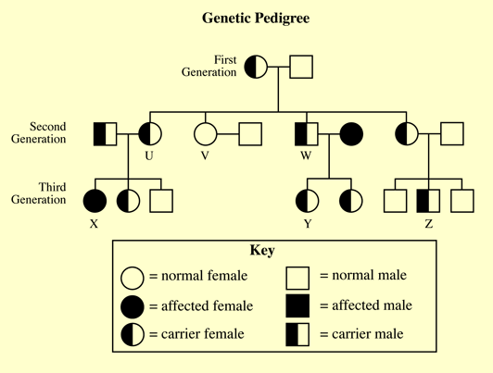
13.) PEDIGREE NOTES:

14.) Compare and contrast sexual and asexual reproduction.

