7th Grade -Natural Selection (SC.7.P.15.1-3)
Natural Selection “Power Notes”:

Highlight key phrases within the power notes below.

Natural selection is the driving force behind evolution. How does it work?
A.) Sexual reproduction and naturally occurring mutations allow for organisms within a species to have slight differences within their traits (variation).
B.) The traits most advantageous (best suited) for survival are then “selected” by nature and passed down to offspring.
C.) This can cause dramatic changes over time within a population and can lead to a NEW SPECIES or EXTINCTION.
D.) Genetic diversity (variation) within a population is important to allow for species survival over time.

***It is important to note that evolution by natural selection does not explain the origin or life (nor does it intend to). Instead, evolution focuses on the idea that species change over time and that not all species alive today were alive in the past.

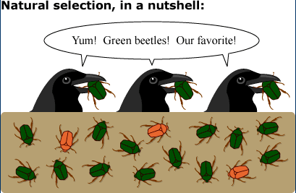
In the cartoon on the left, there are 3 brown beetles and the rest of the beetles are green. All 3 beetles in the bird’s beaks are green as well.

1.) Describe the following terms: genetic variation, adaptation, natural selection, evolution, extinction, species

2.) How might this beetle population change over time?

3.) What is causing the change in the beetle population?

4.) What may have happened if there was no genetic diversity within the beetle population?

5.) How does this cartoon demonstrate evolution by natural selection?
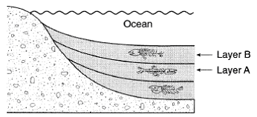
6.) Why is genetic diversity important to a species’ survival?
7.) In the diagram to the right, which layer contains the oldest fossils? Youngest?
8.) How can fossils be used to support the theory of evolution?
9.) What may happen to a species if they are unable to adapt?
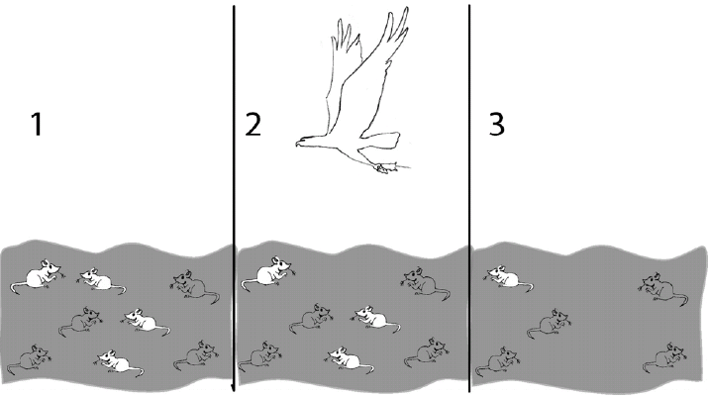
10.) Examine the following statements below and determine how they would affect a species. Create and complete a classification table with the headings, “LEADS TO EXTINCTION” and “HELPS SURVIVAL”:
*Many offspring produced *Few offspring produced
*Rapid environmental change *Slow environmental change
*High genetic variation *Low genetic variation
*Low environmental competition *High competition
*Few limiting factors in environment *Many limiting factors

11.) Explain what is taking place in the picture above.
12.) How does this picture show natural selection?

