7th Grade Review- Energy (SC.7.P.10.1-3) (SC.7.P.11.1-4)

1.) How is the electromagnetic spectrum organized?
2.) Which type of radiation on the E.M.S. had the highest energy (shortest wavelength)?
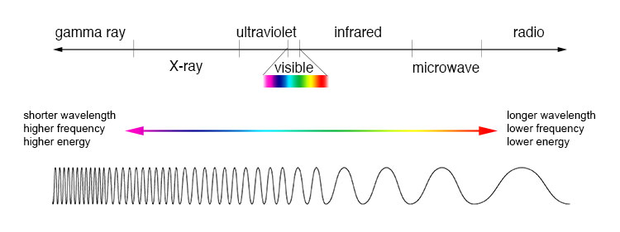
3.) Which type of radiation on the E.M.S. had the lowest frequency (longest wavelength)?
4.) Draw a sketch and provide a definition for the REFLECTION, REFRACTION, and ABSORPTION of light.
5.) Through which material does sound travel fastest through?
6.) In which environment would an electromagnetic wave (such as visible light or radio wave) travel through?
7.) Draw a sketch demonstrating potential energy being converted into kinetic energy. Also provide a 1 sentence explanation of what is occurring.
8.) What is an energy transformation?
9.) List 5 examples of an energy transformation using one of the following energy types: electrical, mechanical (kinetic), sound, thermal, light (electromagnetic), chemical, potential
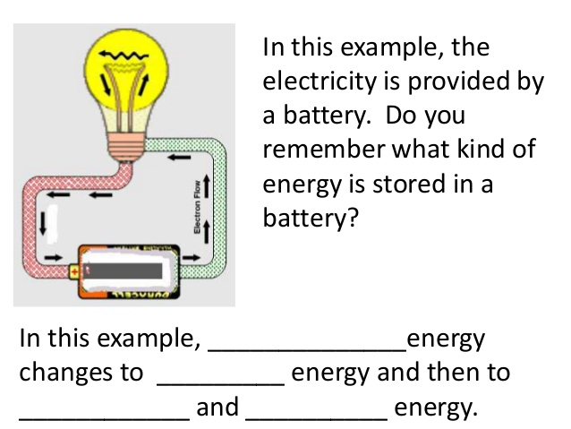
10.)
11.)What type of heat transfer is taking place in
the water? How does this relate to Earth?

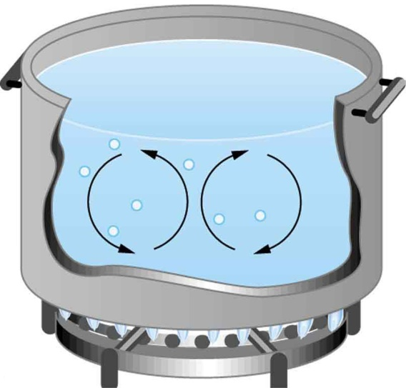

12.) What is the Law of Conservation of Energy?
13.) In what direction does heat travel? (Hint: not up). How long will the heat travel?
14.) List 5 examples of a heat transfer. Label the higher and lower temperature object.
15.) What is specific heat?
16.) How does adding heat change the behavior of atoms?
17.) What are some uses of electromagnetic waves (radiation)? Which electromagnetic waves can be harmful to humans?

