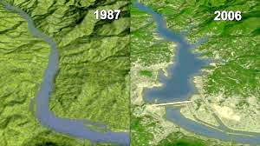
7th Grade -Ecology and Human Impacts (SC.7.P.17.1-3)
1.) Humans have dramatically changed Earth. How has the addition of a water dam negatively impacted the ecosystem to the left? (2 reasons- think about top of dam and after the dam)
2.) What are some other ways that humans have negatively impacted water?
3.) Draw a sketch of urbanization. Below, write a statement explaining how urbanization affects air & water quality.

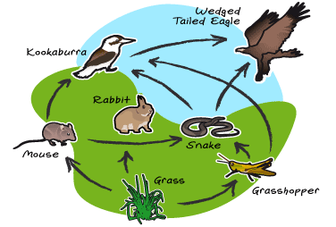
Questions 4-9 are regarding the food web to the left.
4.) The picture to the left is a food web. Food webs show the transfer of C___________ E__________ within an ecosystem.
5.) Which organism would have the highest population (greatest amount of energy available to the ecosystem)?
6.) Which organism is a producer?
7.) Identify the (a) primary (b) secondary and (c) tertiary consumers.
8.) What is an example of competition for food between two organisms within the web?
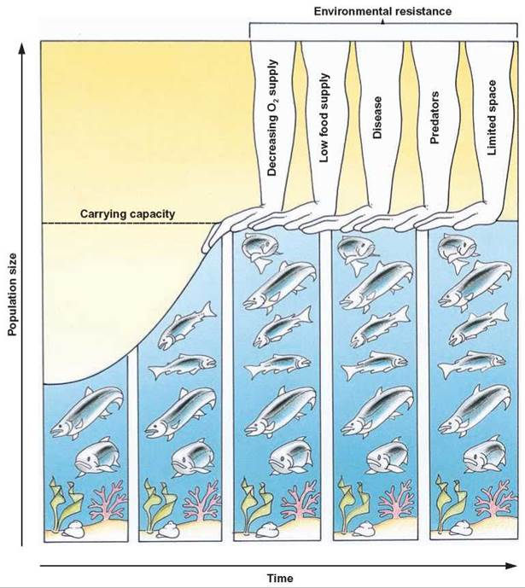
9.) How could populations vary (differ) if the Wedged Tailed Eagle went extinct?
10-14.) Symbiosis describes relationships between organisms within ecosystems. They can be positive, negative, or neutral relationships. Complete the table below regarding types of symbiosis.
Relationship Type | Definition | Example
Mutualism
Commensalism
Parasitism
Predation (Predator/Prey)
Competition
15.) What is a limiting factor within an ecosystem? Provide an example.
16.) Examine the graph to the right. How is this graph related to limiting factors?
17.) How could the sun be considered a limiting factor?
18.) What is a decomposer?
19.) T/F Like plants, fungi photosynthesize.
20.) T/F Tertiary consumers have the largest population in an ecosystem.

