7th Grade Review- Earth Stuff (SC.7.E.6.1-7)
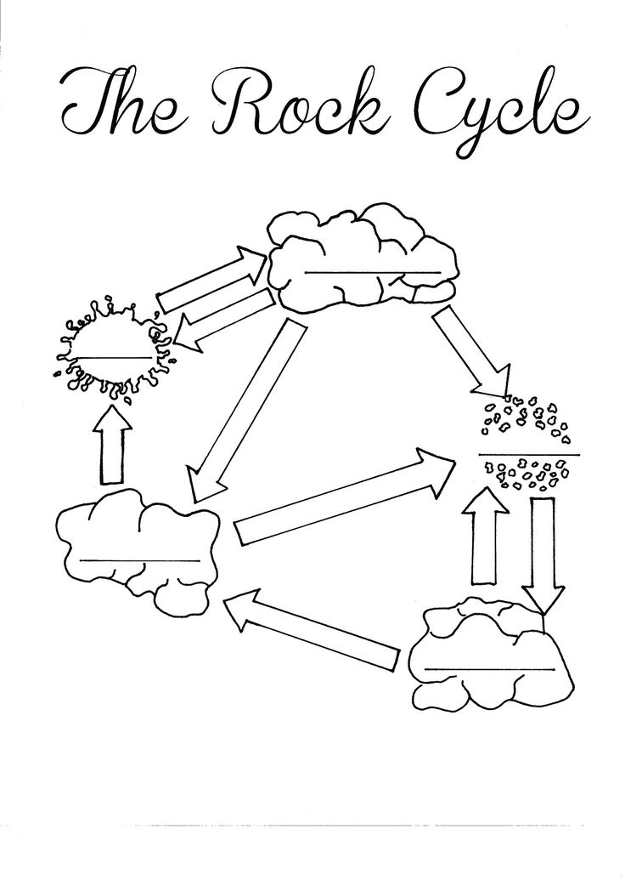
1.) Using the template to the left as your guide, recreate the diagram of the rock cycle on a separate sheet of paper. Be sure to label the arrows and demonstrate how all 3 rock types are formed. (Also show magma and sediments)
2.) How might weathering and erosion cause changes to Earth?
3.) How are erosion and deforestation related?
4.) Which type of rock would fossils most likely be located within?
5.) The 3 chemical layers of the Earth are the ________________, ________________, and _________________(inner and outer).
6.) What is the Theory of Plate Tectonics?
7.) What is a tectonic plate?
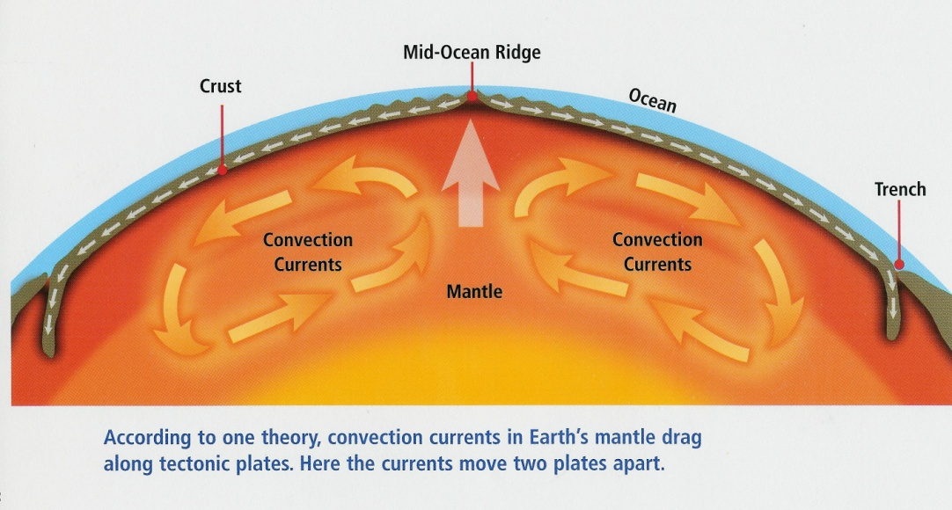
8.) Using the image below for guidance, describe heat transfer within Earth’s mantle.
9.) Describe the process of an earthquake.
10.) What is the difference between weathering, erosion, and deposition of sediment?
11.) What is the Law of Superposition?
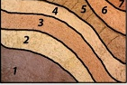
12.) Examine the rock layer below. Which layer is oldest? Youngest?
13.) Examine the picture above of the hot convecting mantle and lithosphere resting on top. What is an example of a SLOW CHANGE and a RAPID (FAST) CHANGE that could result from the movement of Earth’s lithosphere and mantle.
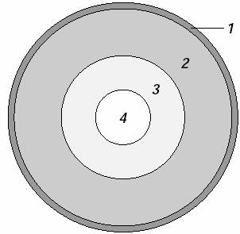
14.) Which layer of Earth would contain the densest materials? Why?
15.) What is radioactive dating and what is it used for?
16.) Examine the halved view of Earth to the right. In
which layer of Earth are the convection currents that
directly result in tectonic plate motion found?

