6th Grade Review –Human Body Systems (SC.6.P.14.5-6)

1.) Complete the classification table below highlighting the major function of organ systems within the human body:
ORGAN SYSTEM | FUNCTION | IMPORTANT FEATURES
DIGESTIVE |  | mouth, stomach, liver, intestines, anus
EXCRATORY |  | bladder, kidneys, liver, urethra, skin
RESPIRATORY |  | nose, pharynx, trachea, bronchi, lungs
CIRCULATORY |  | blood, heart, lungs
REPRODUCTIVE |  | genitalia & gamete producers (ovaries/testicles)
MUSCULAR/SKELETAL |  | muscles, skeleton, tendons, ligaments, joints
IMMUNE |  | bone marrow, thymus, t cells
NERVOUS |  | brain, spinal cord, nerves
NOTE:
For the purpose of the exam, you will not need to match the “important features” with its organ system. The test will also not ask you to simply recall the organ system’s function individually. Instead, questions will be related to HOW 2 or more of these body systems interact and work together in the human body for survival.

2.) How would the nervous and muscular body systems work together in response to entering a cold environment?
3.) How do the respiratory and circulatory body systems interact together during an organism’s daily activities?
4.) How do the nervous and digestive body systems interact with each other?
5.) Provide 3 specific examples describing how organ systems work together to maintain homeostasis within the body.
6.) Compare and contrast the 3 types of infectious agents that can infect the human body: VIRUS, BACTERIA, FUNGUS

~~~~~~~~~~~~~~~~~~~ Classification of Life (SC.6.P.15.1) ~~~~~~~~~~~~~~~~~~~
Classification “Power Notes”
The Kingdoms in Domain Eukarya include Animals, Plants, Fungi, and Protists. Bacteria are in their own separate Domain (NO nucleus)
Highlight key phrases below:
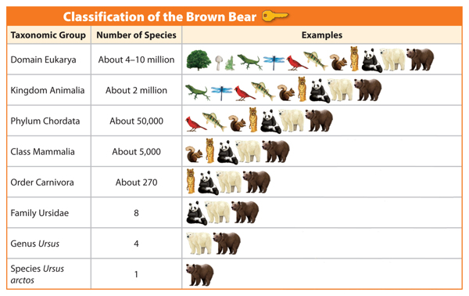
********************************
Organisms are classified by their similar characteristics. A classification technique called the “Linnaen system” is used by scientists globally. This allows scientists from all over the world to agree on a unified way to organize life on Earth.

The largest branch is the DOMAIN (Eukarya, Bacteria, and Archaea).

Organisms within Eukarya are EUKARYOTIC, meaning there is a nucleus present in each cell. Bacteria are PROKARYOTIC, meaning that they do not have a nucleus. Bacteria are not in Eukarya.
Dear Kate, Please Come Over For Good Soup

(Domain, Kingdom, Phylum, Class, Order, Family, Genus, Species)

Every organism has a scientific name (binomial nomenclature). It is the genus and species name combined. For example, the brown bear is Ursus arctos. Humans are classified as Homo sapiens.
***********************************
1.) Organisms are classified by similar characteristics. Define the following terms used to classify life: (A.) Prokaryotic
(B.) Eukaryotic (C.) Heterotroph (D.) Autotroph (E.) Multicellular (F.) Unicellular
2.) T/F Fungi are classified as autotrophs.
3.) T/F Green Plants are classified as autotrophs.
4.) T/F Humans are classified as heterotrophs.
5.) T/F Fungi are multicellular and are therefore classified in the Domain Eukarya.
6.) T/F Bacteria are multicellular organisms and are therefore classified in the Domain Eukarya.
7.) T/F Fungi are classified as prokaryotic organisms.

