6th Grade Review –Forces and Motion (SC.6.P.12.1) (SC.6.P.13.1)
1.) Forces are often simply described as being a “push or a pull”. What is the scientific definition of a force?
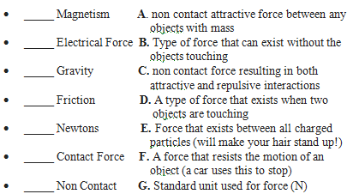
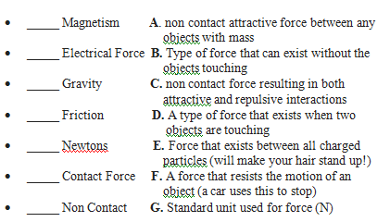
2.) Match the terms with their description:

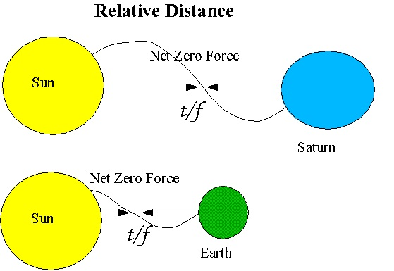
3.) Use the picture below to describe in 2-3 sentences how the following are related: (a) gravity and mass, (b) gravity and distance.
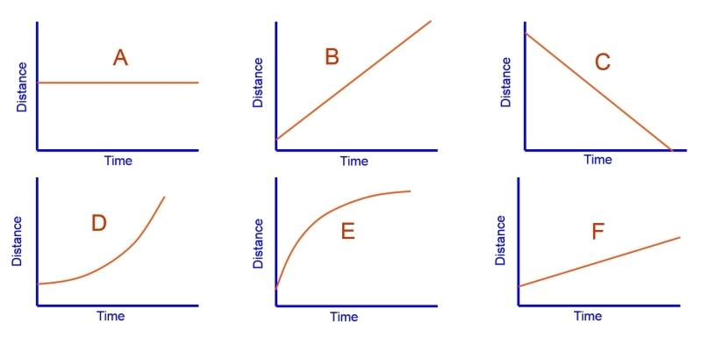
DISTANCE VS. TIME GRAPH
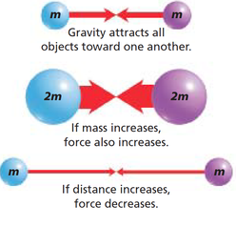
4.) Complete the statements:
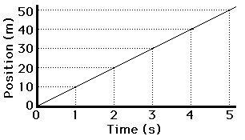
5.) Examine the graphs above. Pretend it’s showing the distance over time of various
C
cars traveling along the interstate. Which graph shows a car: (A) not moving at
all, (B) accelerating faster over time (positive acceleration), (C) getting slower
over time (negative acceleration) and (D) moving at a constant speed (3 answers)?
6.) Which car is traveling faster: B or F? How do you know?
7.) Examine the graph to the left. Let’s still talk cars. Car C is moving at a constant
speed. Plot and label 2 separate lines on the graph showing (A) a car traveling at
a faster constant speed and (B) a car traveling at a slower constant speed.
8.) What is the difference between mass and weight?
9.) How would your weight compare on our moon vs. Earth? How would your mass compare?
10.) On which planet would you weigh the least? Why?
11.) Which planet has the strongest gravitational attraction? Why?
12.) Scientifically describe the results of the two tug-of-war games below.
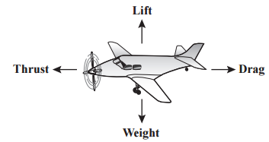
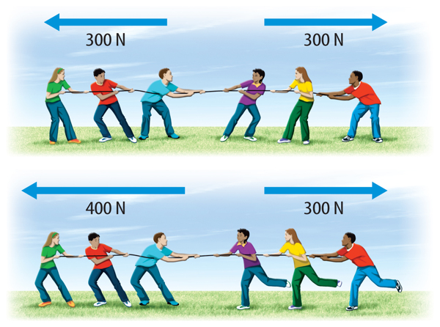
13.) What would cause the model airplane to descend to the ground?
A. The lift equals drag
B. The lift is less than the weight
C. The thrust is equal to weight
D. The thrust is greater than the drag

14.) Sketch a roller coaster (or any object you can think of) to demonstrate changes in potential and kinetic energy. Show at what point there is minimum/maximum potential energy and minimum/maximum kinetic energy.

