6th Grade Review- Earth Stuff (SC.7.P.7.1-9)
- What is the difference between conduction, convection, and radiation?
- Provide an example of conduction, convection, and radiation IN NATURE.
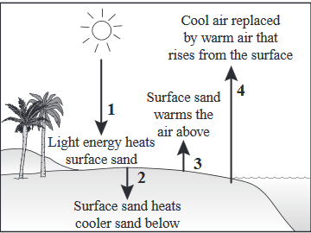
- Examine the diagram below. Label the four arrows below as conduction, convection, or radiation.
- The model below shows various wind patterns found on
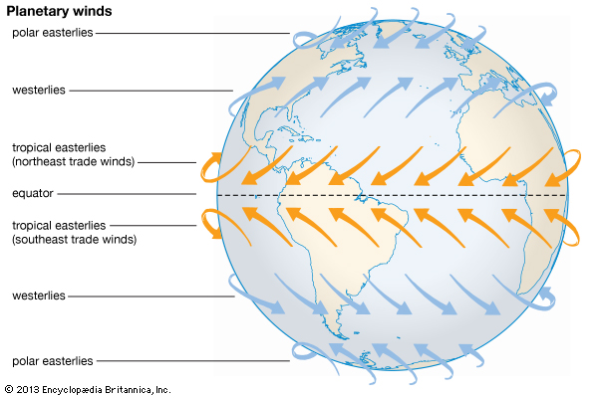
Earth. What are the 2 major reasons why wind occurs?
- Which heat transfer method does wind use?
- When energy from the sun hits the air above land, the air warms and rises. Along a coastline, cooler air above the ocean flows towards the land to replace the rising air. Which 2 heat transfer types are in this example? Explain.
- What is the difference between weather and climate?
- Evaluate the following statements and determine if they are an example of weather or climate:
  - There should be rain tomorrow morning.
  - The average temperature from 1930-1966 was 23°C (74°F).
  - The majority of Florida has a humid subtropical environment.
  - It is sunny outside today. Tomorrow should be sunny as well.
  - The high temperature on September 4, 2009, was 32°C (89°F).
  - Typically, rainfall in June will always be under 1 inch.
  - It has not rained this month yet.
- The “Earth system” is all of the matter, energy, and processes within Earth’s boundary. Earth’s system can be broken into five major “spheres”: geosphere, hydrosphere, cryosphere, biosphere, and atmosphere. Create a table that describes what each sphere is composed of.
- Name 3 benefits Earth receives from having a protective atmosphere. (think about a planet like Mercury, which has little to no atmosphere)
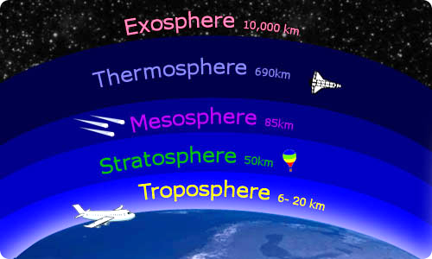
- Earth’s spheres are not isolated from each other. In fact, they are constantly interacting by exchanging matter and energy. Using the table you created from #9, Determine which 2-3 spheres are interacting with each other in the following scenarios:
  - Rain provides water for living things on Earth.
  - The deer carcass is being decomposed into the ground by many different organisms.
  - Water waves break in shallow areas.
  - Icebergs melt in the sun and pool into nearby oceans.
  - Water in the lake begins to evaporate into the air on a hot summer day.
- What is the OZONE LAYER? How does the ozone layer benefit Earth?
- The picture on the right shows layers of Earth’s atmosphere. What information do scientists use to classify the different layers?
- What is a JET STREAM and how does it affect air travel?
- The water cycle on Earth has 4 major components: precipitation, evaporation, condensation, and sublimation. Create a small table that organizes and explains each process.

